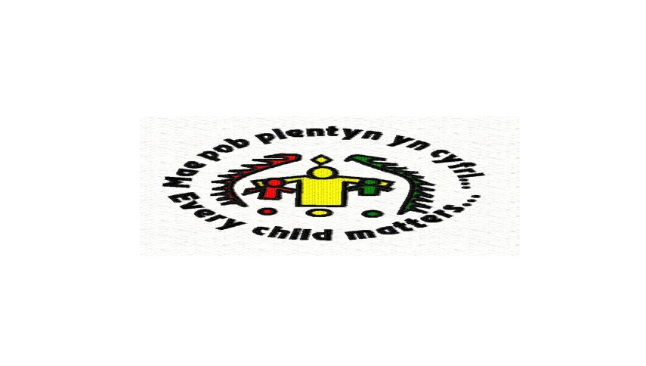Summer Term Newsletter 2018

[](http://www.google.co.uk/url?sa=i&rct=j&q=&esrc=s&source=images&cd=&cad=rja&uact=8&ved=0ahUKEwjaguLD-Z_UAhXB6xQKHTodBz4QjRwIBw&url=http://edenprairieweblogs.org/policedepartment/posts/5330/&psig=AFQjCNHB5JJwJJR7v4Wpq0xXRM1D3BMxTQ&ust=1496519949473982)

Ceredigion Pupil Referral Unit

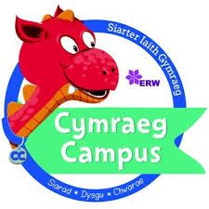



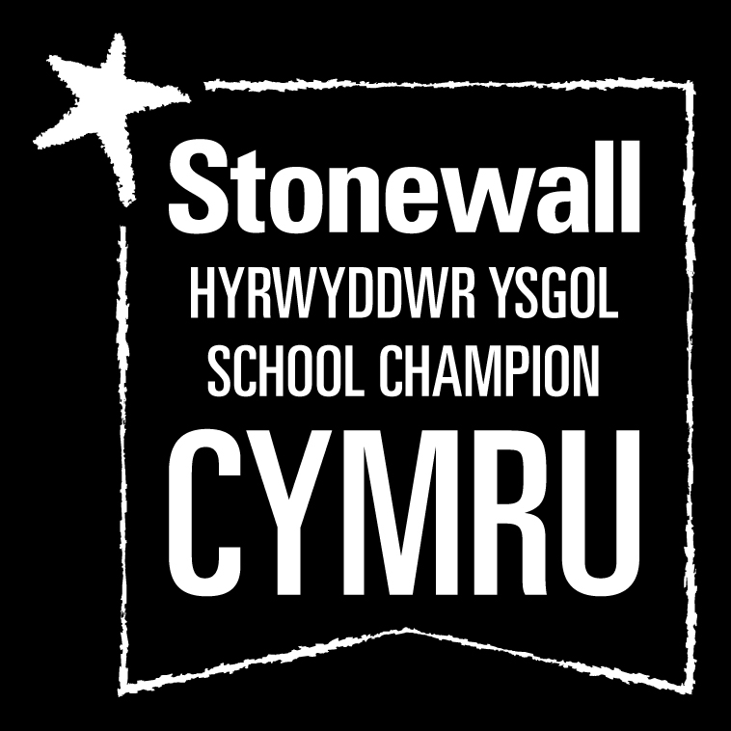









It has been another very busy term at Ceredigion PRU this Summer with a wide variety of exciting learning opportunities organised for our pupil. We hope you enjoy reading about our successes and please provide us with feedback!

**Key Stage 2 – Canolfan yr Eos**

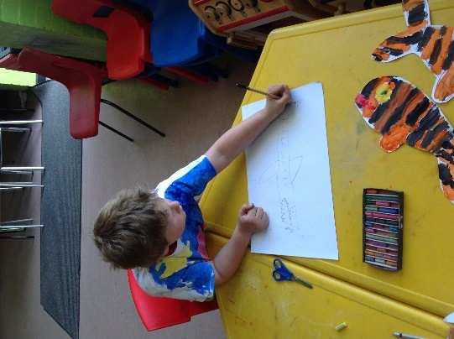We have had a jam-packed term in Key Stage 2 this summer term. Alongside our exciting curriculum themes of **“Water, Water Everywhere**” and **“The world of Sports”-** we have been involved with many other learning activities. One of our highlights has been our sessions with Art Therapist Miss Manda Clements where we have made our own t-shirts and bags which has been one of our favourites yet. We have also enjoyed the valuable weekly Mindfulness sessions delivered by the ERW Trainer Gareth in Aberaeron. Our pupils have learnt techniques and strategies to improve their self-regulation and emotional health. This is being used in our classrooms with some really positive effects for our pupils.

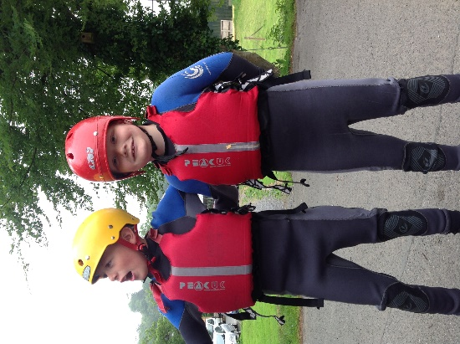In addition, during Summer Sports Week we had the opportunity to try surfing, walking up Nant yr Arian and kayaking with Paddlers in Llandysul. Despite a few falls from both staff and pupils; fun was had by all. Next year we are looking to try some stand up paddle boarding!

Due to chicken pox we were unable to attend our planned Folly Farm trip this year. But we are heading to the local Fantasy Farm in a couple of weeks and are looking forward to feeding the animals and playing in the outdoor sand area. The pupils have worked hard this final term and undoubtedly deserve a day out!!

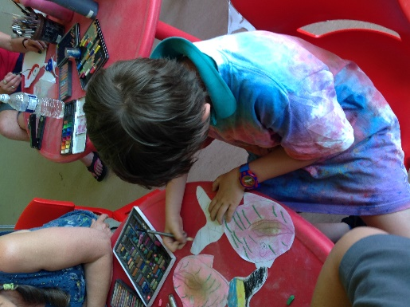Every Friday we have been having rugby sessions at our local club with the areas rugby development coach. These sessions have ignited and interest with all of our pupils in the sport and we thank Llyr for his support in working with our pupils this term.

Our pupils have been re-integrating positively into their mainstream schools and have been engaging in a range of lessons throughout the school day. Pupils are settling back in well to mainstream school and their busy classrooms. We look forward to seeing further progress when we return in September.

**Charlie Sproulle Teacher in Charge of Eos KS 2 Unit**

**Key Stage 3 – Canolfan Bro Steffan**

Key Stage 3 pupils have had a very busy term at Canolfan Bro Steffan. We’ve taken part in several different activities in a range of different subjects. The highlight was Summer Sports Week, where students had the opportunity to kayak, river swim, paddle board and hike around Ceredigion. Each day required the pupils to learn and practice a new skill which they did excellently. We are looking forward to next year already!

Surfing with Aber Adventures in Borth continues to be an enjoyable extra-curricular activity and the pupils at Bro Steffan are making excellent progress. Everyone is now able to paddle out and catch waves confidently (with the odd fall here and there)! We have also been lucky enough to start a bike maintenance course, where pupils are learning to identify problems and fix bicycles. So far, everyone has made very good progress and pupils are already able to replace and repair tyres.

Pupils have also began learning how to write code at Canolfan Bro Steffan. Learners have already been able to design and animate their own Google logo and are working towards being able to manipulate and improve games. A pleasing start to the new Digital Literacy Framework at the PRU.

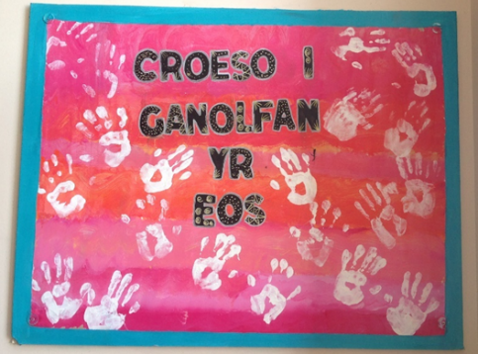

**Gareth Lewis Teacher in Charge of KS 3 Bro Steffan**

**Key Stage 3 & 4 – Canolfan yr Eos**

Work has continued during the summer term decorating the new Canolfan yr Eos centre. Thank you so much to Manda Clements our Art therapy teacher for being such a fantastic team leader and an inspiration in this endeavour. All our pupils have worked diligently on every project and have left their mark on our hand print welcome wall!! Thank you to all our pupils for your hard work.

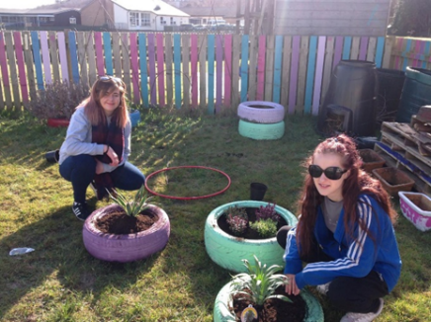Our pupils have been busy with a gardening project as part of our Wellbeing week. Staff and pupils had a fantastic time sprucing up the PRU garden by painting the fence in different bright pastel colours and painting the tyres in to brighten them up before planting flowers and shrubs. It looks fantastic and is a secure, tranquil place that is used daily by our pupils.

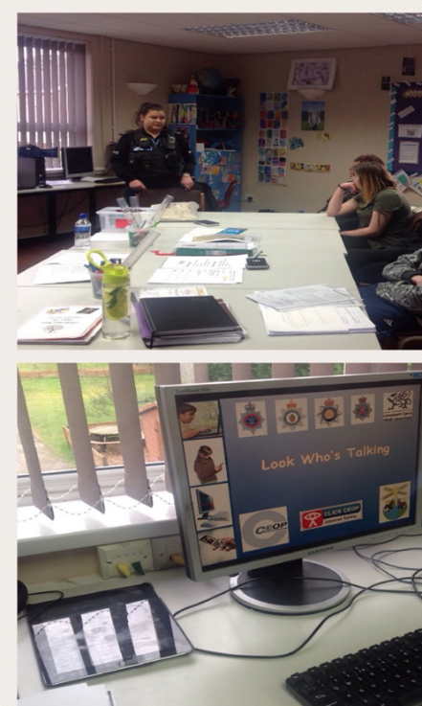A big thank you to PC Hannah Evans and Nurse Sioned Burrell for being so willing to visit the Eos as part of our PSE Programme again this term. Each session was informative but humorous which was enjoyed by our pupils and staff alike. Lots of valuable learning to remember!

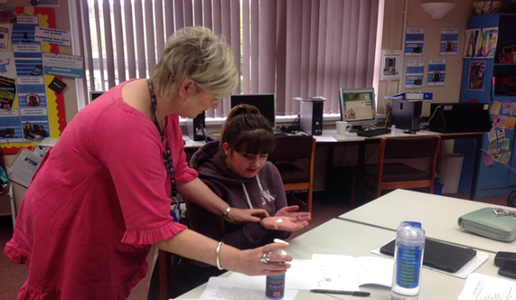

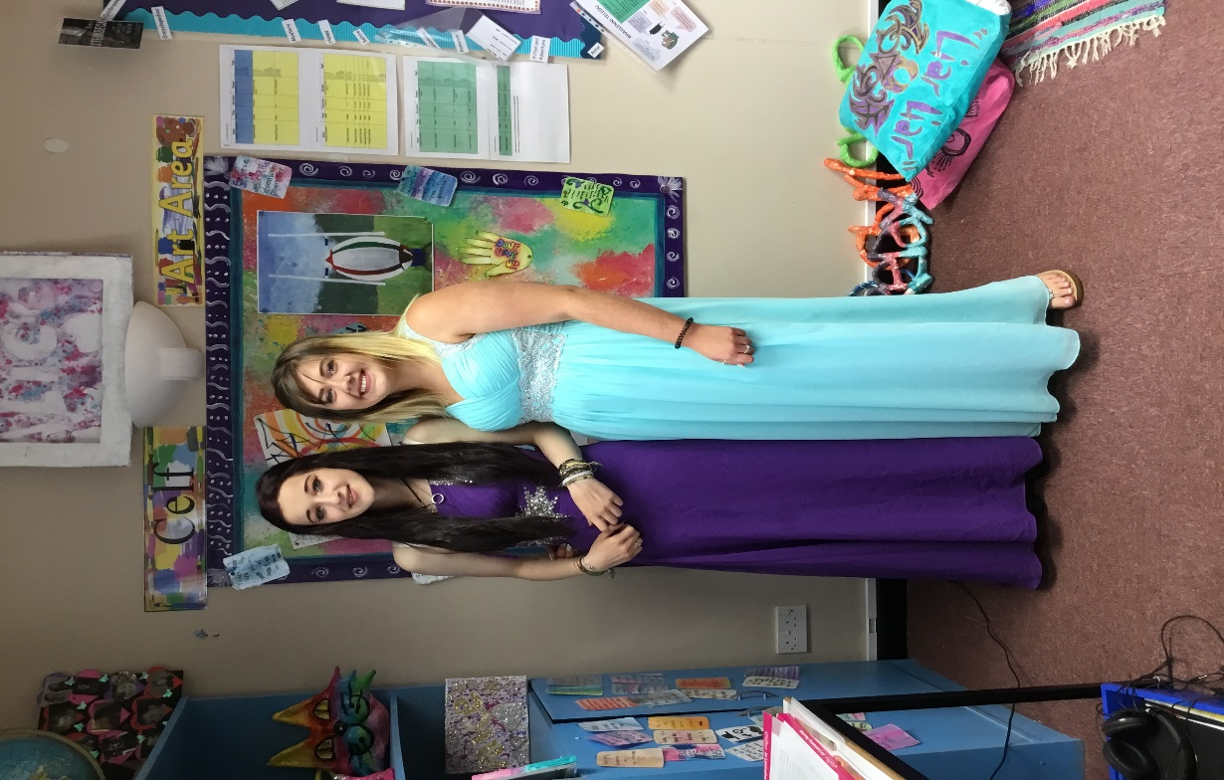

**Eos Leavers Day!!**

It was with mixed emotions that we said goodbye to our ‘Year 11 Leavers’ at the end of May. We had a lovely day full of celebrations. After a morning of reminiscing and pampering we all went out for a meal joined by our Year 10’s to say goodbye and good luck to Year 11. Afterwards back in the centre all the families gathered for a photographic session. Thank you to all the families for all your support and thank you Suzanne Fearn from Siwis Photography for making our pupils feel so relaxed and taking wonderful photographs of them.

**Alwen Roberts & Jan Pargeter KS 4 Eos Teachers**

**Key Stage 4 - Canolfan Aeron**

It has been a very busy term for KS4 in Canolfan Aeron. Mrs Christine Evans went on her maternity leave just before Easter and we congratulate her on the birth of her beautiful baby girl who arrived on April 12th.

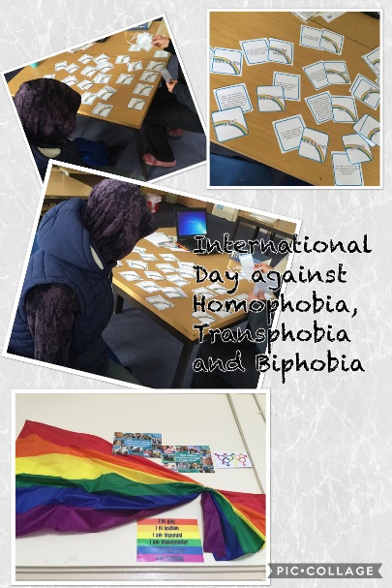The focus of the past term has been to support the health and wellbeing of the students and we have focussed on healthy-eating and cooking, mental health and emotional wellbeing. Some students and staff have been participating in a ‘Mindfulness’ course which has taken place over 8 weeks and all have seen the benefits of practicing mindfulness in their everyday lives.

We celebrated the International Day Against Homophobia, Transphobia and Biphobia on May 17th and had some interesting and well-informed discussions which allayed some outdated beliefs.

One of the pupils has been working alongside the lovely people in Ray Ceredigion for the past few months every Friday cooking for the Dementia-friendly group ‘Forget-me-Not’. She has enjoyed the experience and has been asked to continue into the summer. Work experience placements have been successful for two other students, one in a local cafe and another in a local butchers – well done both!

We have also had GCSE examinations and the stresses and anxiety they bring! We are very proud of our pupils for giving their best efforts to the exams;

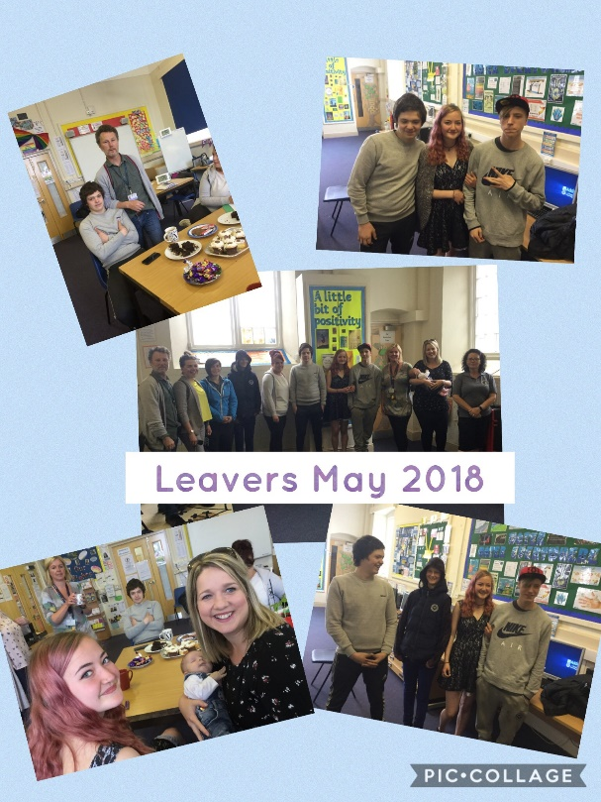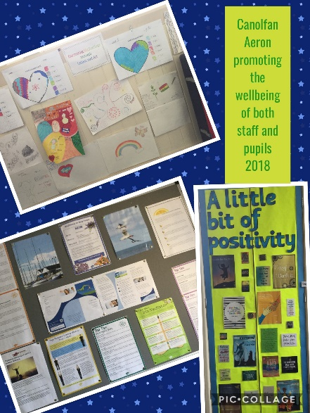

‘Leavers’ took place on May 25th following the busy GCSE period. Pupils and staff enjoyed tea and coffee and plenty of home-baked cakes and a visit from Mrs Evans along with her new addition. It was a lovely morning and then chips on the harbour wall finished it all off. The stress of the exams had passed and there were plenty of smiles and hand-shakes when we parted. We hope that some of the pupils will call and see us and update us with the progress they make in college and work placements. We would like to thank all of school leavers and wish them well for the future. We look forward to hearing how you get on.

The weather has been hot and the students have been part of Sports Week which has taken them Surfing in Borth, Paddle-boarding in New Quay and kayaking in Llandysul Paddlers. We are not sure who enjoyed it the most – the staff or the pupils. It has been a lovely way to enjoy the good weather and develop positive relationships with our new students. We can’t wait for next year’s activities already!

We are very proud of a Year 11 pupil whose poem was chosen out of thousands of entries in a National Poetry Competition to be published in a book called **“Poetry Games-Voices from Wales”.** The Poem is entitled: “Be Safe on-line” and the book will be out in shops to buy this coming Autumn 2018!!

KS 4 Aeron Pupils just love Cooking! We have already begun their Jamie Oliver BTEC and have mastered Chicken Chow Mein, Pizza and Spaghetti Bolognese amongst other recipes to date. Masterchef here we come! We have also taken part in Caribbean Cookery Sessions and explored multi-cultural identity via global gourmet! A wonderful experience was had by all and KS 3 Pupils also joined us for the day- Diolch Nia Jenkins a Sonia Ellis Jones o dîm YJPS am drefnu.

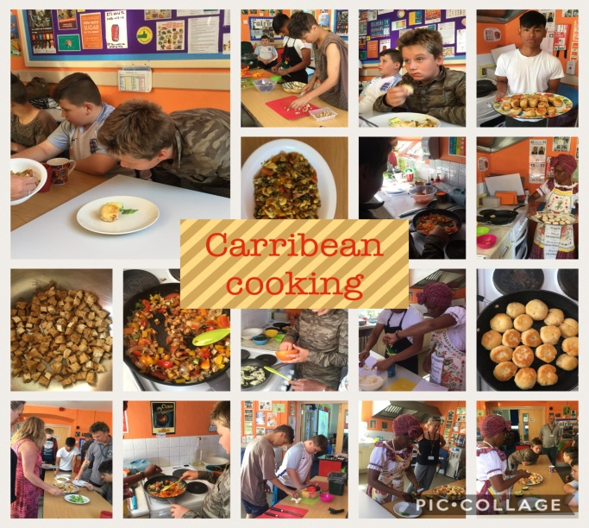

We cannot believe that yet another academic year has flown by and are looking forward to 2018-2019 and the successes it will bring for our pupils!

**Mike Vobe KS 4 Aeron Teacher and Lorraine Davies HLTA KS4**

**(Christine Evans: Teacher in Charge is on Maternity Leave)**

**A Little Reminder!**

Ceredigion PRU Website and Twitter!!

We have been busy working hard to create the Ceredigion PRU website and we are now LIVE. The website is there to inform parents, pupils and staff alongside informing of all the fantastic work which goes on daily. There is a calendar with upcoming events, photo galleries and also our twitter is linked which means that our tweets are uploaded instantly for all to see what’s going on during our busy days. Please have a browse and let us know what you think - http://ceredigion.ceredigion.sch.uk/ - . Our new school Twitter is also now set up so please follow,like and tweet us to spread the word @Ceredigionpru1.

**Summer 2018: An end of Term Note…!**

**Dear All,**

**Thank you for your continued hard work and commitment to the pupils of Ceredigion PRU - this year has been full of little successes and positive developments in our provision. Highlights include: Lego Intervention, Relationship Based Play and Mindfulness and Yoga Sessions as well as Parent Workshops to name but a few! Each unit environment and Garden is looking amazing – thank you to all pupils and staff who have worked hard to achieve such a welcoming and warm environment in each unit. You are an amazing, brilliant team and deserve every praise for your efforts!**

**We have continued to gain quality marks this year - which is testament to our continued efforts to provide the best provision for the children in our care. They include: Phase 3 Ysgolion Iach Plaque, Cymraeg Campus Bronze Award, Rights of the Child Bronze Award and the Stonewall Badge. Next year, we will aim to complete our second Eco Flag, Phase 4 Ysgolion Iach Plaque, Silver Award for Cymraeg Campus and continue on our journey to become a Rights Respecting PRU.**

**We say a fond farewell to 9 Year 11 pupils this year and I would like to take this opportunity to wish them well in their future education, employment or training. All have gained a place at college next year and we wish them continued success.**

**Over the Summer break, we will continue to support some of you as our pupils in fun projects and hope that you will participate in summer events organized by Ceredigion Youth Service and RAY Ceredigion.**

**I wish you all a relaxing Summer break and Keep Safe!**

**Kind Regards,**

**Angharad John-Head of Ceredigion PRU**

Bro Steffan